PYTHON
Python is a general-purpose interpreted, interactive, object-oriented, and high-level programming language. An interpreted language, Python has a design philosophy that emphasizes code readability (notably using whitespace indentation to delimit code blocks rather than curly brackets or keywords), and a syntax that allows programmers to express concepts in fewer lines of code than might be used in languages such as C++or Java. It provides constructs that enable clear programming on both small and large scales. Python interpreters are available for many operating systems. CPython, the reference implementation of Python, is open source software and has a community-based development model, as do nearly all of its variant implementations. CPython is managed by the non-profit Python Software Foundation. Python features a dynamic type system and automatic memory management. It supports multiple programming paradigms, including object-oriented, imperative, functional and procedural, and has a large and comprehensive standard library
DJANGO
Django is a high-level Python Web framework that encourages rapid development and clean, pragmatic design. Built by experienced developers, it takes care of much of the hassle of Web development, so you can focus on writing your app without needing to reinvent the wheel. It’s free and open source.
Django's primary goal is to ease the creation of complex, database-driven websites. Django emphasizes reusabilityand "pluggability" of components, rapid development, and the principle of don't repeat yourself. Python is used throughout, even for settings files and data models.
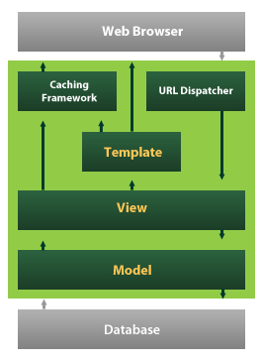
Django also provides an optional administrative create, read, update and delete interface that is generated dynamically through introspection and configured via admin models

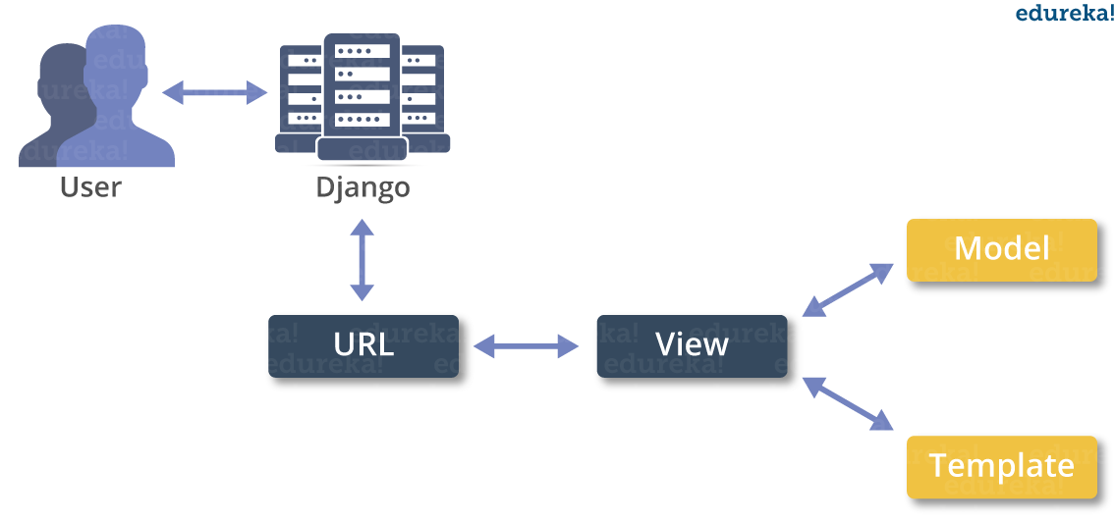
Python is a programming language, which means it’a a language both people and computers can understand. Python was developed by a Dutch software engineer named Guido van Rossum, who created the language to solve some problems he saw in computer languages of the time.
Python is an interpreted high-level programming language for general-purpose programming. Created by Guido van Rossum and first released in 1991, Python has a design philosophy that emphasizes code readability, and a syntax that allows programmers to express concepts in fewer lines of code, notably using significant whitespace. It provides constructs that enable clear programming on both small and large scales.
Python features a dynamic type system and automatic memory management. It supports multiple programming paradigms, including object-oriented, imperative, functional and procedural, and has a large and comprehensive standard library.
Python interpreters are available for many operating systems. C Python, the reference implementation of Python, is open source software and has a community-based development model, as do nearly all of its variant implementations. C Python is managed by the non-profit Python Software Foundation.
You Can Use Python for Pretty Much Anything
One significant advantage of learning Python is that it’s a general-purpose language that can be applied in a large variety of projects. Below are just some of the most common fields where Python has found its use:
- Data science
- Scientific and mathematical computing
- Web development
- Computer graphics
- Basic game development
- Mapping and geography (GIS software)
Python Is Widely Used in Data Science
Python’s ecosystem is growing over the years and it’s more and more capable of the statistical analysis.
It’s the best compromise between scale and sophistication (in terms od data processing).
Python emphasizes productivity and readability.
Python is used by programmers that want to delve into data analysis or apply statistical techniques (and by devs that turn to data science)
There are plenty of Python scientific packages for data visualization, machine learning, natural language processing, complex data analysis and more. All of these factors make Python a great tool for scientific computing and a solid alternative for commercial packages such as MatLab. The most popular libraries and tools for data science are:
Pandas: a library for data manipulation and analysis. The library provides data structures and operations for manipulating numerical tables and time series.
NumPy: the fundamental package for scientific computing with Python, adding support for large, multi-dimensional arrays and matrices, along with a large library of high-level mathematical functions to operate on these arrays.
SciPy: a library used by scientists, analysts, and engineers doing scientific computing and technical computing.
Being a free, cross-platform, general-purpose and high-level programming language, Python has been widely adopted by the scientific community. Scientists value Python for its precise and efficient syntax, relatively flat learning curve and the fact that it integrates well with other languages (e.g. C/C++).
As a result of this popularity there are plenty of Python scientific packages for data visualization, machine learning, natural language processing, complex data analysis and more. All of these factors make Python a great tool for scientific computing and a solid alternative for commercial packages such as MatLab.
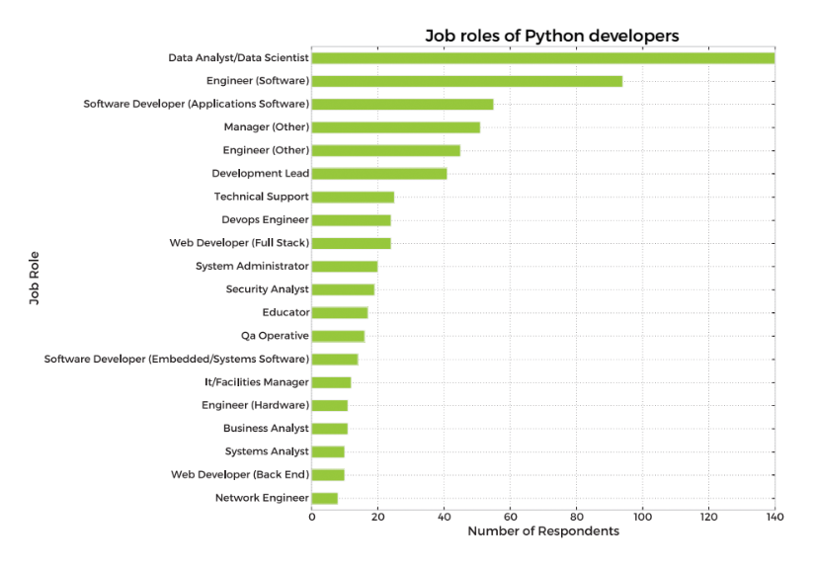
Here’s our list of the most popular Python scientific libraries and tools
Astropy
The Astropy Project is a collection of packages designed for use in astronomy. The core astropy package contains functionality aimed at professional astronomers and astrophysicists, but may be useful to anyone developing astronomy software.
Biopython
Biopython is a collection of non-commercial Python tools for computational biology and bioinformatics. It contains classes to represent biological sequences and sequence annotations, and it is able to read and write to a variety of file formats.

Cubes
Cubes is a light-weight Python framework and set of tools for the development of reporting and analytical applications, Online Analytical Processing (OLAP), multidimensional analysis and browsing of aggregated data.
DEAP
DEAP is an evolutionary computation framework for rapid prototyping and testing of ideas. It incorporates the data structures and tools required to implement most common evolutionary computation techniques such as genetic algorithm, genetic programming, evolution strategies, particle swarm optimization, differential evolution and estimation of distribution algorithm.
SCOOP
SCOOP is a Python module for distributing concurrent parallel tasks on various environments, from heterogeneous grids of workstations to supercomputers.
PsychoPy
PsychoPy is a package for the generation of experiments for neuroscience and experimental psychology. PsychoPy is designed to allow the presentation of stimuli and collection of data for a wide range of neuroscience, psychology and psychophysics experiments.
Pandas
Pandas is a library for data manipulation and analysis. The library provides data structures and operations for manipulating numerical tables and time series.
Mlpy
Mlpy is a machine learning library built on top of NumPy/SciPy, the GNU Scientific Libraries. Mlpy provides a wide range of machine learning methods for supervised and unsupervised problems and it is aimed at finding a reasonable compromise between modularity, maintainability, reproducibility, usability and efficiency.

matplotlib
Matplotlib is a python 2D plotting library which produces publication quality figures in a variety of hardcopy formats and interactive environments across platforms. Matplotlib allows you to generate plots, histograms, power spectra, bar charts, errorcharts, scatterplots, and more.
NumPy
NumPy is the fundamental package for scientific computing with Python, adding support for large, multi-dimensional arrays and matrices, along with a large library of high-level mathematical functions to operate on these arrays.
NetworkX
NetworkX is a library for studying graphs which helps you create, manipulate, and study the structure, dynamics, and functions of complex networks.
TomoPy
TomoPy is an open-sourced Python toolbox to perform tomographic data processing and image reconstruction tasks. TomoPy provides a collaborative framework for the analysis of synchrotron tomographic data with the goal to unify the effort of different facilities and beamlines performing similar tasks.
Theano
Theano is a numerical computation Python library. Theano allows you to define, optimize, and evaluate mathematical expressions involving multi-dimensional arrays efficiently.
SymPy
SymPy is a library for symbolic computation and includes features ranging from basic symbolic arithmetic to calculus, algebra, discrete mathematics and quantum physics. It provides computer algebra capabilities either as a standalone application, as a library to other applications, or live on the web.
SciPy
SciPy is a library used by scientists, analysts, and engineers doing scientific computing and technical computing. SciPy contains modules for optimization, linear algebra, integration, interpolation, special functions, FFT, signal and image processing, ODE solvers and other tasks common in science and engineering.
Scikit-learn
Scikit-learn is a machine learning library. It features various classification, regression and clustering algorithms including support vector machines, random forests, gradient boosting, k-means and DBSCAN, and is designed to interoperate with the Python numerical and scientific libraries NumPy and SciPy.
Scikit-image
Scikit-image is a image processing library. It includes algorithms for segmentation, geometric transformations, color space manipulation, analysis, filtering, morphology, feature detection, and more.
ScientificPython
ScientificPython is a collection of modules for scientific computing. It contains support for geometry, mathematical functions, statistics, physical units, IO, visualization, and parallelization.
SageMath
SageMath is mathematical software with features covering many aspects of mathematics, including algebra, combinatorics, numerical mathematics, number theory, and calculus. SageMath uses the Python, supporting procedural, functional and object-oriented constructs.
Veusz
Veusz is a scientific plotting and graphing package designed to produce publication-quality plots in popular vector formats, including PDF, PostScript and SVG.
Graph-tool
Graph-tool is a module for the manipulation and statistical analysis of graphs.
SunPy
SunPy is a data-analysis environment specializing in providing the software necessary to analyze solar and heliospheric data in Python.

Bokeh
Bokeh is a Python interactive visualization library that targets modern web browsers for presentation. Bokeh can help anyone who would like to quickly and easily create interactive plots, dashboards, and data applications. Its goal is to provide elegant, concise construction of novel graphics in the style of D3.js, but also deliver this capability with high-performance interactivity over very large or streaming datasets.
TensorFlow
TensorFlow is an open source software library for machine learning across a range of tasks, developed by Google to meet their needs for systems capable of building and training neural networks to detect and decipher patterns and correlations, analogous to the learning and reasoning which humans use. It is currently used for both research and production at Google products,‍ often replacing the role of its closed-source predecessor, DistBelief.
Nilearn
Nilearn is a Python module for fast and easy statistical learning on NeuroImaging data. Nilearn makes it easy to use many advanced machine learning, pattern recognition and multivariate statistical techniques on neuroimaging data for applications such as MVPA (Mutli-Voxel Pattern Analysis), decoding, predictive modelling, functional connectivity, brain parcellations, connectomes.
Dmelt
DataMelt, or DMelt, is a software for numeric computation, statistics, analysis of large data volumes ("big data") and scientific visualization. The program can be used in many areas, such as natural sciences, engineering, modeling and analysis of financial markets. DMelt can be used with several scripting languages including Python/Jython, BeanShell, Groovy, Ruby, as well as with Java.
Python-weka-wrapper
Weka is a suite of machine learning software written in Java, developed at the University of Waikato, New Zealand. It contains a collection of visualization tools and algorithms for data analysis and predictive modeling, together with graphical user interfaces for easy access to these functions. The python-weka-wrapper package makes it easy to run Weka algorithms and filters from within Python.
Dask
Dask is a flexible parallel computing library for analytic computing composed of two components: 1) dynamic task scheduling optimized for computation, optimized for interactive computational workloads, and 2) Big Data collections like parallel arrays, dataframes, and lists that extend common interfaces like NumPy, Pandas, or Python iterators to larger-than-memory or distributed environments.
Python Saves Time
Even the classic “Hello, world” program illustrates this point:
print("Hello, world")
For comparison, this is what the same program looks like in Java:
public class HelloWorld {
public static void main(String[] args) {
System.out.println("Hello, world");
}
}
All the Big Names Use Python
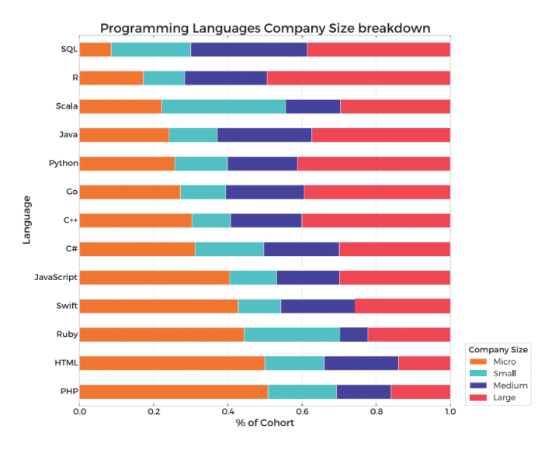
Python Keywords and Identifier
Keywords are the reserved words in Python.
We cannot use a keyword as variable name, function name or any other identifier. They are used to define the syntax and structure of the Python language.
In Python, keywords are case sensitive.
There are 33 keywords in Python 3.3. This number can vary slightly in course of time.
All the keywords except True, False and None are in lowercase and they must be written as it is. The list of all the keywords is given below.
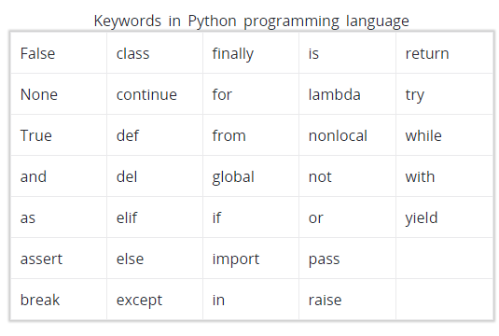
Identifier is the name given to entities like class, functions, variables etc. in Python. It helps differentiating one entity from another.
Rules for writing identifiers
Identifiers can be a combination of letters in lowercase (a to z) or uppercase (A to Z) or digits (0 to 9) or an underscore (_). Names like myClass, var_1 and print_this_to_screen, all are valid example.
An identifier cannot start with a digit. 1variable is invalid, but variable1 is perfectly fine.
Keywords cannot be used as identifiers.
>>> global = 1
File "<interactive input>", line 1
global = 1
^
SyntaxError: invalid syntax
We cannot use special symbols like !, @, #, $, % etc. in our identifier.
>>> a@ = 0
File "<interactive input>", line 1
a@ = 0
^
SyntaxError: invalid syntax
Identifier can be of any length.

Python
Python features a dynamic type system and automatic memory management. It supports multiple programming paradigms, including object-oriented, imperative, functional and procedural, and has a large and comprehensive standard library.
Python interpreters are available for many operating systems. C Python, the reference implementation of Python, is open source software and has a community-based development model, as do nearly all of its variant implementations. C Python is managed by the non-profit Python Software Foundation.
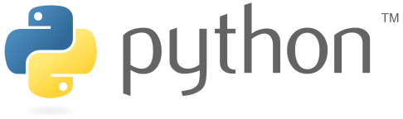
Python Logo

